1. Scaling:
   * vertical: instead of more servers we will have one big server which can hold multiple services like (which can control DB,web..etc)
     + con: limited when its getting bigger, single point of failure
     + pro : less maintenance
   * Horizontal: multiple servers with load balancing
     + con : high maintenance, will work out with stateless
     + pro : SOF can be addressed, can be scale infinitely

which one to go : chose the simplest architecture that meets your project traffic requirements but no simpler

1. Failover strategies:
   * what kind of servers are their?
     + on premise (company owned)
     + cloud services (amazon ec2, google compute engine, azure VMs)
     + Fully managed "serverless" services (i.e., amezon lambda,kinesis,athena)
   * Failover servers
     + Cold Standby: keeping the backup in tapes/dsks/..etc (periodic) . if DB crashers backup will be restored to anther server and traffic pointer to new
       - con : downtime till new server ready, back up may fail, data loss during fail
     + Warm standby : replication service which can be replicated in real time
       - con : tiny window of data loss
     + Hot standby : instead of replication webserver will wire data in multiple dbs simultaneously. fit in horizontal scale
       - con : more resource utilization
   * scaling databases
     + Horizontal scale: Sharding
       - web pointing to multiple shard dbs with their backups
       - 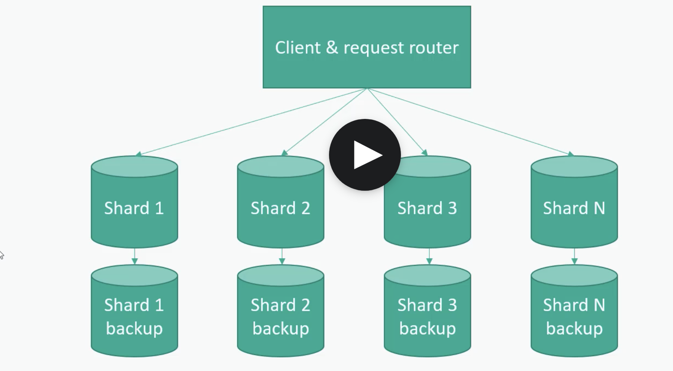
       - Since the data distributed multiple shards combining them is the challenge
         * To mitigate we need key value-based hashes to take to required shard
         * Typical example is Mango DB which is nosql server no relationship maintained

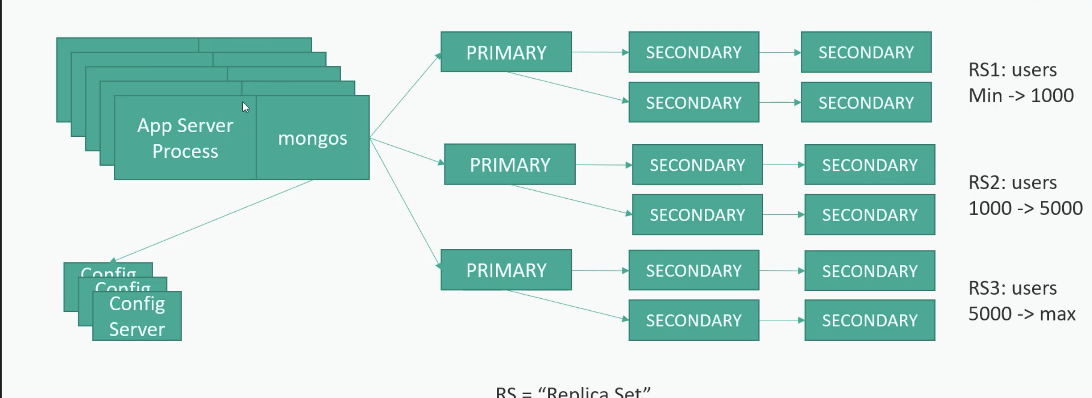

RS : replica set

RS will be controlled by mongos

Primary routing to secondary to load data

In case of primary fails any one of the secondary can act as primary

Config server will supports mongos for data distribution (primary secondary server details..etc)

Atlease 3 primary and config servers are defined to avoild SPF

Cons : maintenance is high as we are maintaining more backups just to make wait if any one of fails

* + - * + Another example is Cassandra

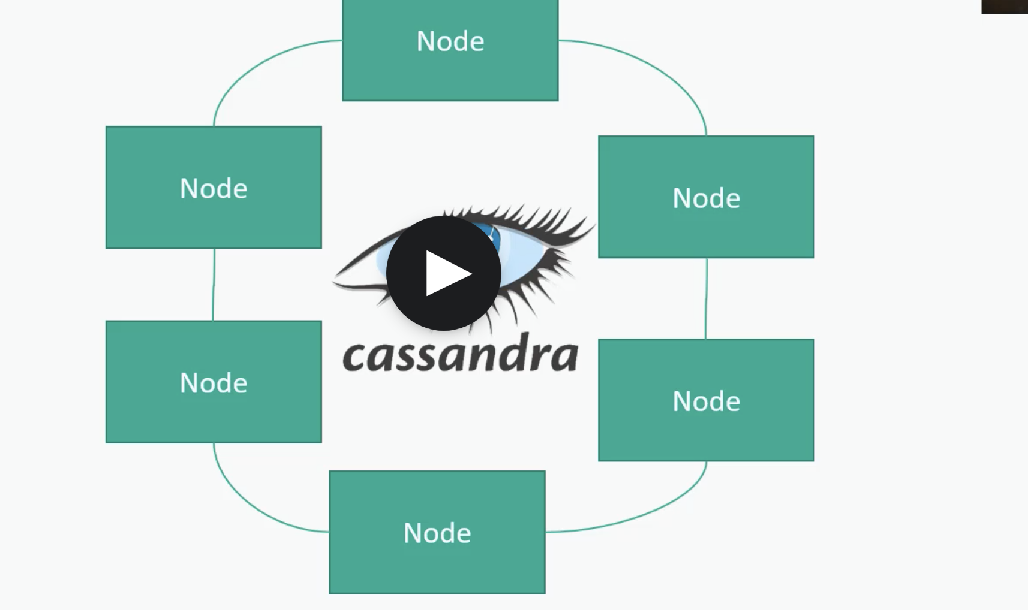

Any one of the node can be act as primary

Data will be replicated to all the nodes which is con all nodes should know the data

Tradeoff is eventual consistency (as ready may takes time as it has to replicate to other nodes which may not be immediately available)

* + - * Sharded databases some times called as “No SQL”
        + Tough to do join across shards
        + Resharding (as scaling up its need to be refined)
        + Hotspots (most frequent search/accessible items)
        + Most no sql databases actually supports most sql operations and use sql as their API
        + Still works best with simple key/value lookups
        + A formal schema may not be required
        + Ex: Mongo,cassendra,DynamoDB,HBase
      * Data representation
        + 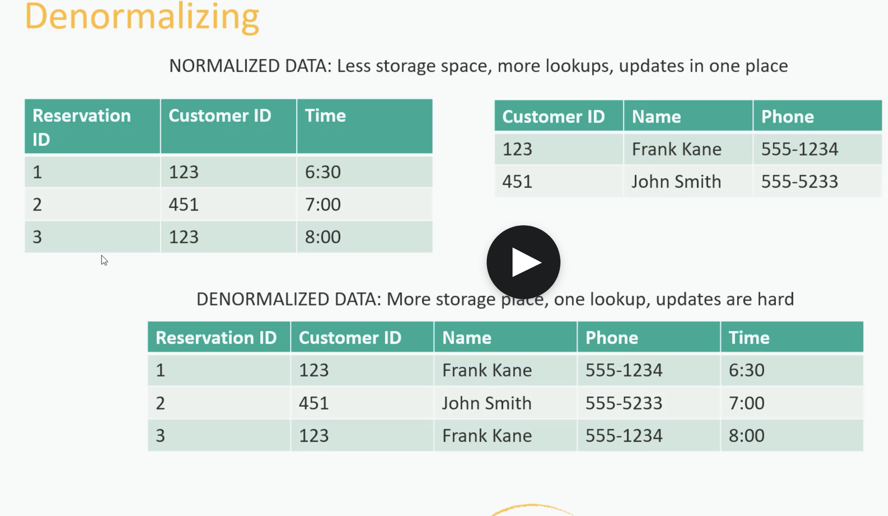
        + In no sql we need to have 2 queries to get data from 2 tables as data my be shred and no relation. So we need to consider which one is suitable based on the out application usage point of view
        + If not sure its better to go with normalization then if it can be converted to denormalization later
      * Cloud Solutions/Data lakes
        + Just throw data into text files (csv,json,) into a big distribution storage system like Amezon S3

This is called data lake

Common approach for big data and unstructured data

* + - * + Another process(amezon glue) create schema for that data
        + And cloud based features that allows you to queries data

Amazon antenna (server less)

Amazon redshift(distributed data warehouse)

* + - * + We still need to to think how to partition raw data for best performance
        + Sample architecture

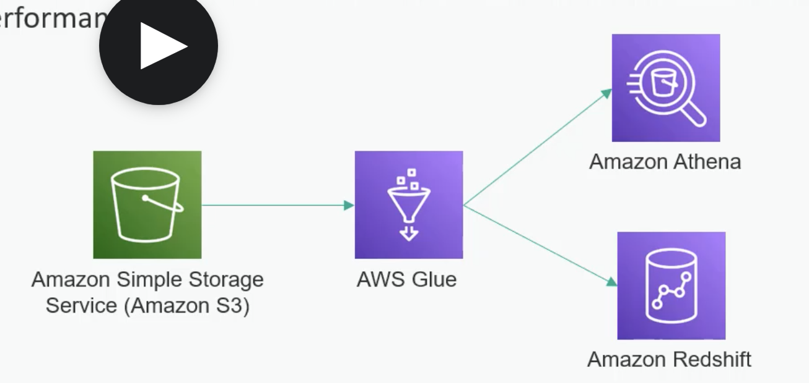

S3 for log files which can be backed up by glue that can be retrieved by anthena/redshift

1. ACID Compliance (DBMS standards)
   * + Atomicity
       - Either entire transaction success or failed.
         * If anything fails everything has to be rollback
         * Everything has to be performed all at once
     + Consistency
       - All data base rules are enforced or the entire transaction is rollbacked
     + Isolation
       - No transaction is affected by other while it is in process
     + Durability
       - Once transaction is committed it stays even if system crashes immediately after
2. CAP Theorem
   1. In ACID, we can’t get all at once as . we need to compromise one or other. So we will follow CAP theorem
      1. 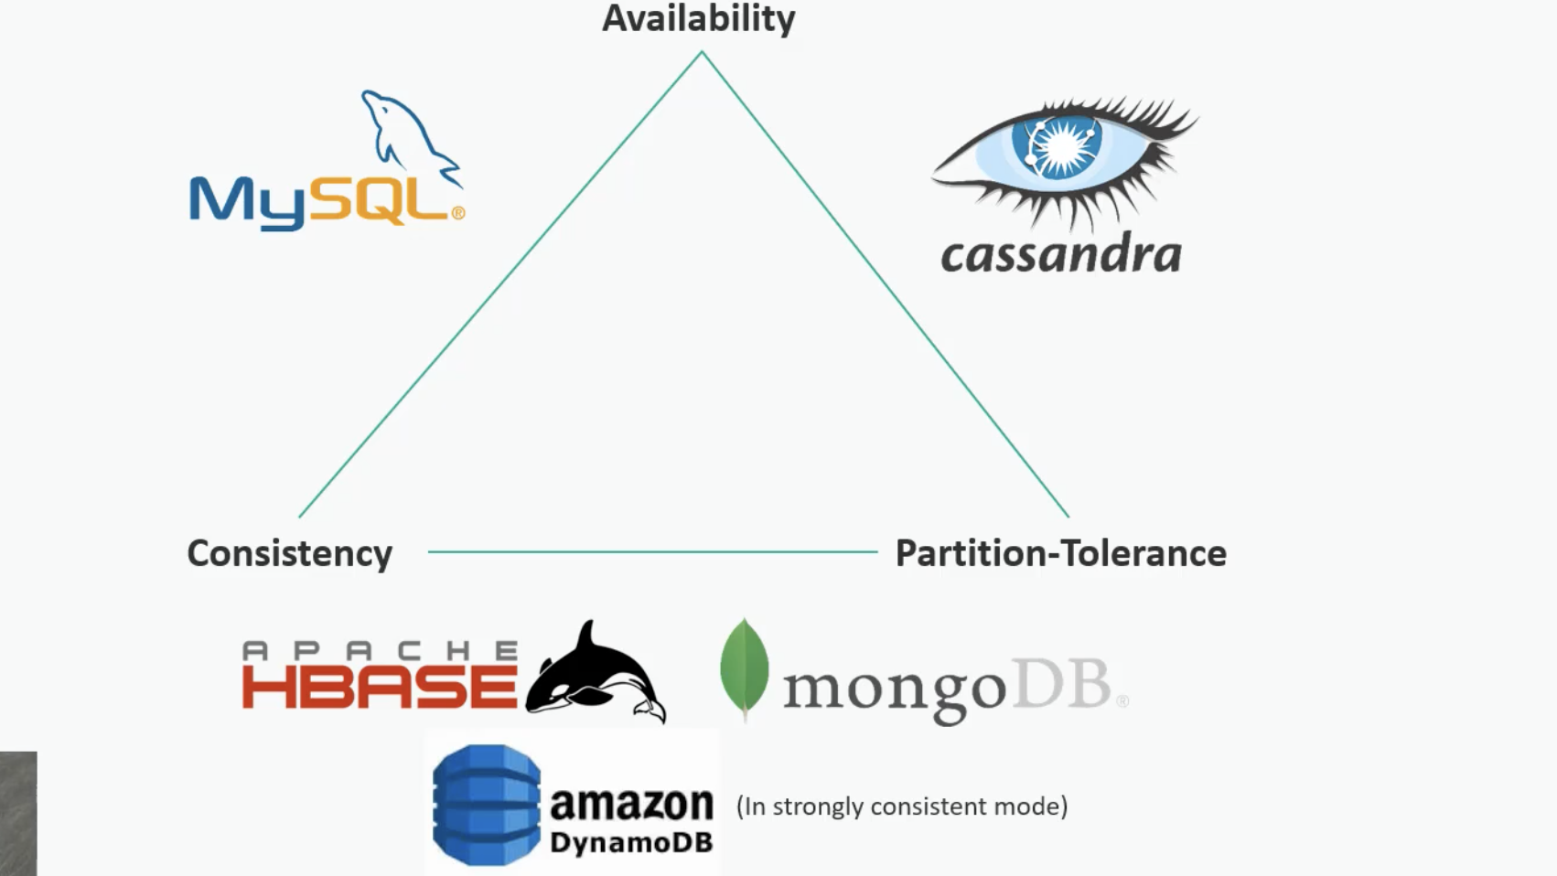
         1. We can pick any 2 not 3 based on application
            1. Partition-tolerance is like durability
3. Caching
   1. Modern system should not only give preference to scaling alone we need to consider the performance aswell
   2. Technologies:
      1. Caching layer
         1. 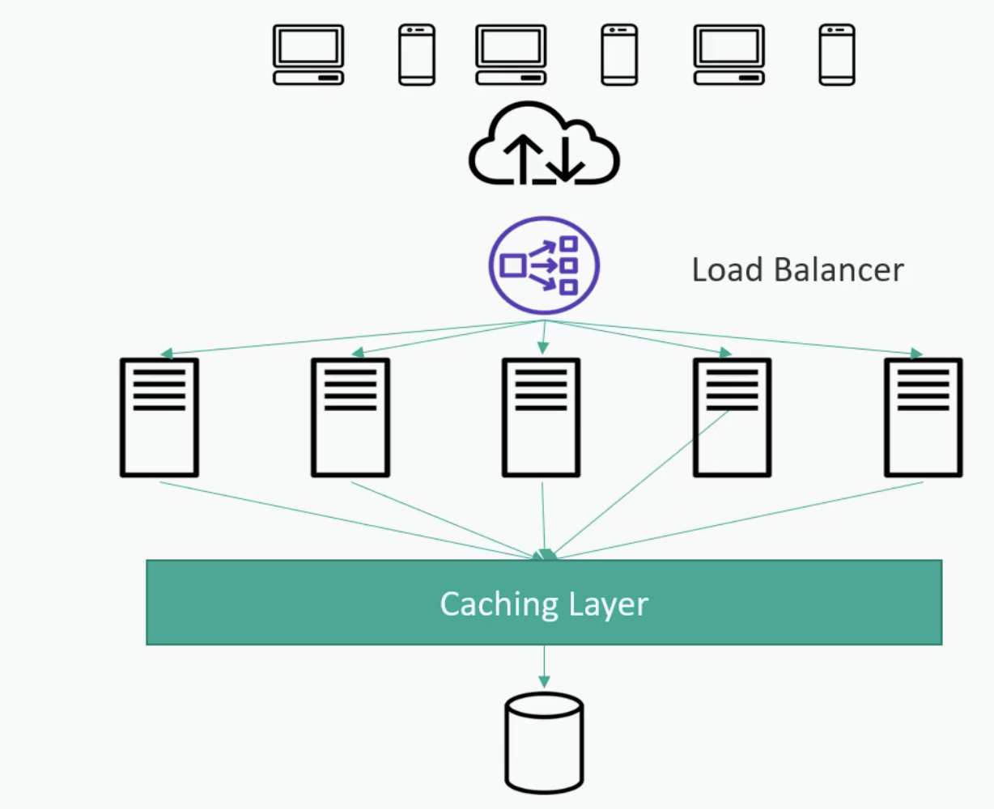
      2. How cache works
         1. Horizontally scaled servers
         2. Client hash requests to given servers
         3. In memory -fast
         4. Appropriate for application who does more reads than writes
         5. Expiration policy dictates how long data is cached. Too long it may go for state too short may not give fruit full performance
         6. Hotspot can be a problem
         7. Cold start also a problem. How do you initially warmup cache without brining sown what ever we are caching
         8. 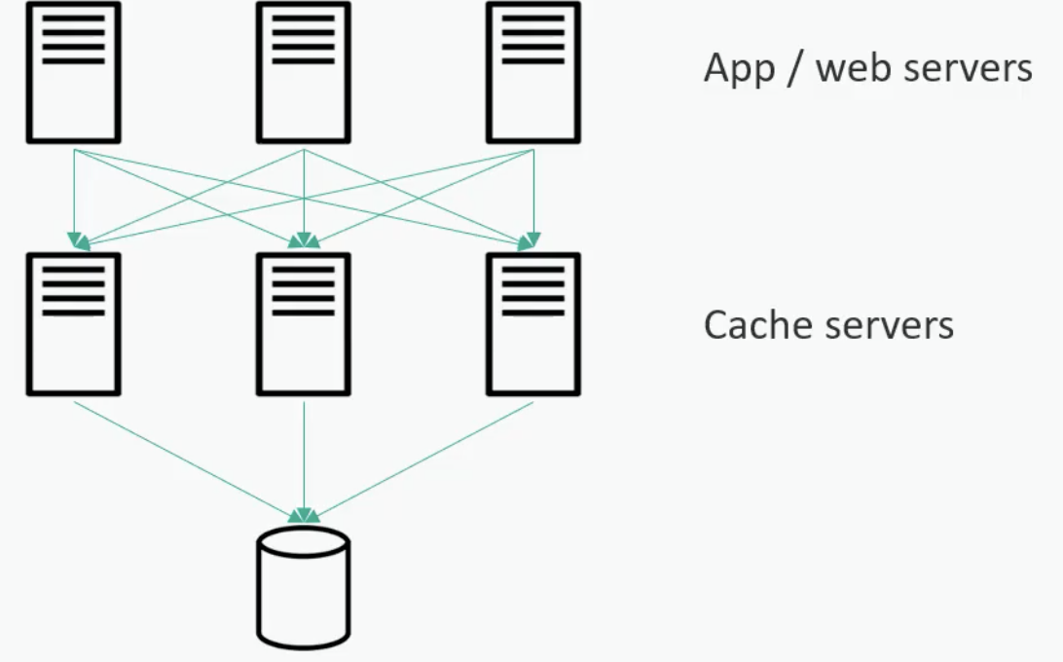
      3. Eviction Policies
         1. LRU : least recently used
            1. 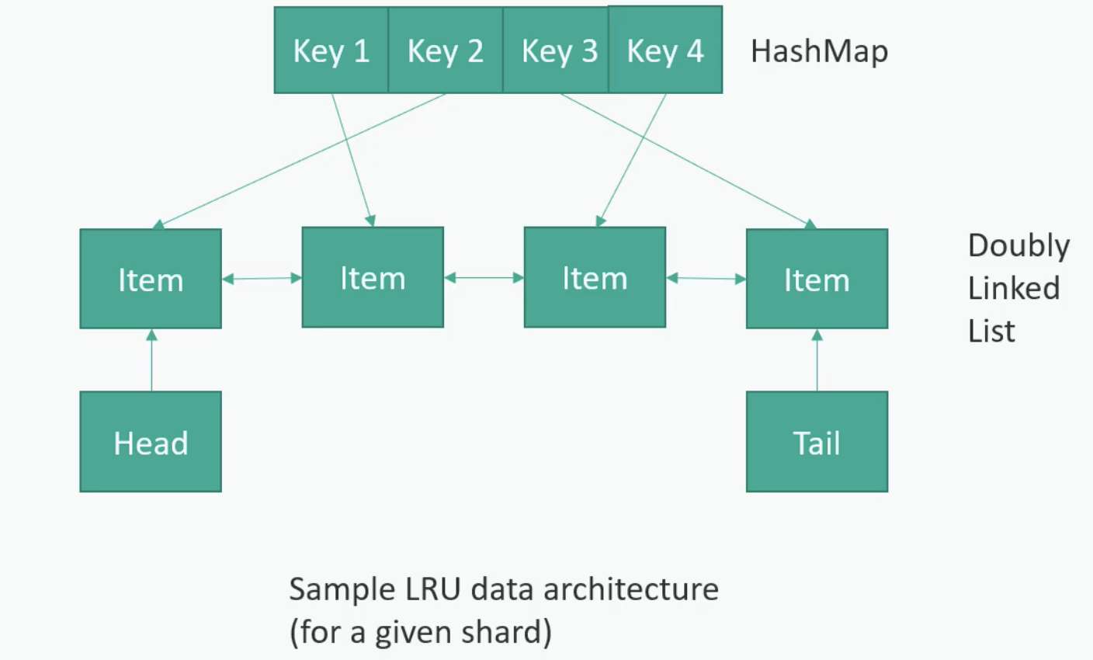
         2. LFU : least frequently used
         3. FIFO : First in first out
         4. 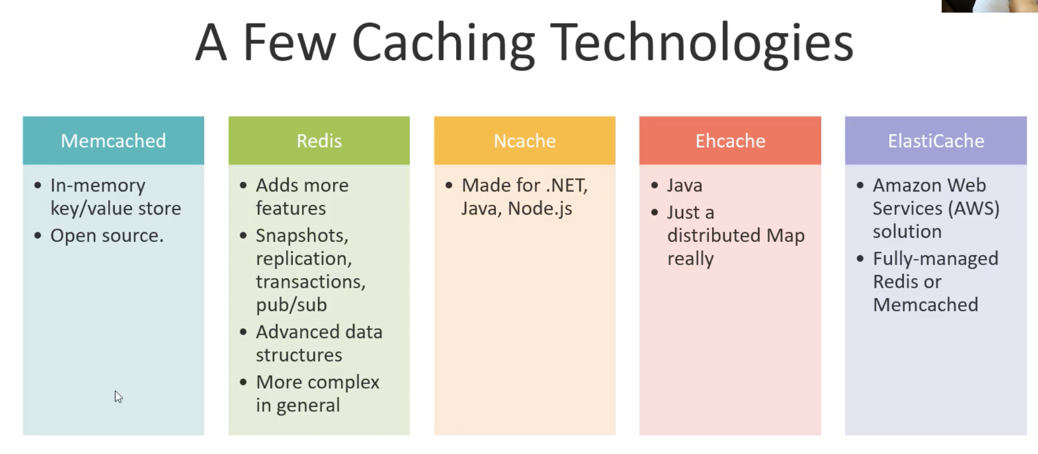
   3. Content Delivery Networks(CDN)
      1. 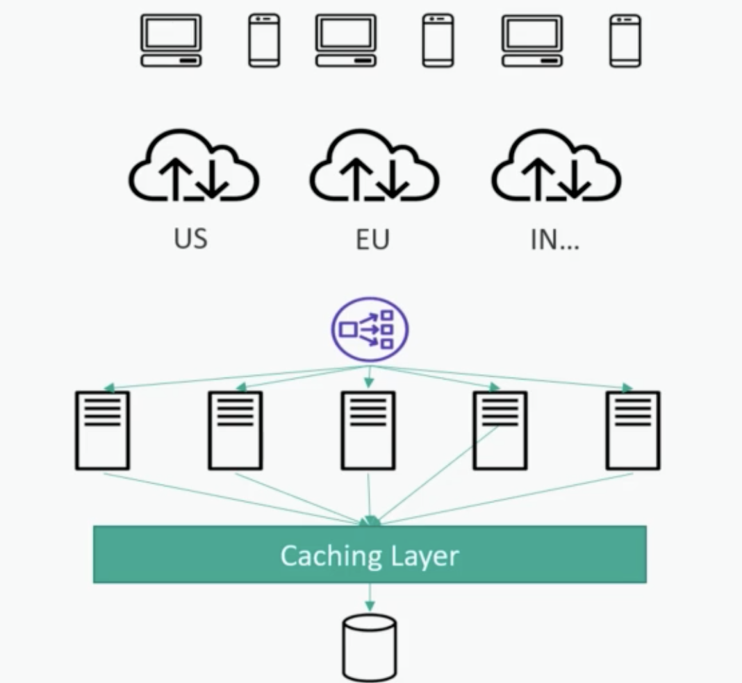
      2. Mostly serving static pages
      3. CDN providers
         1. 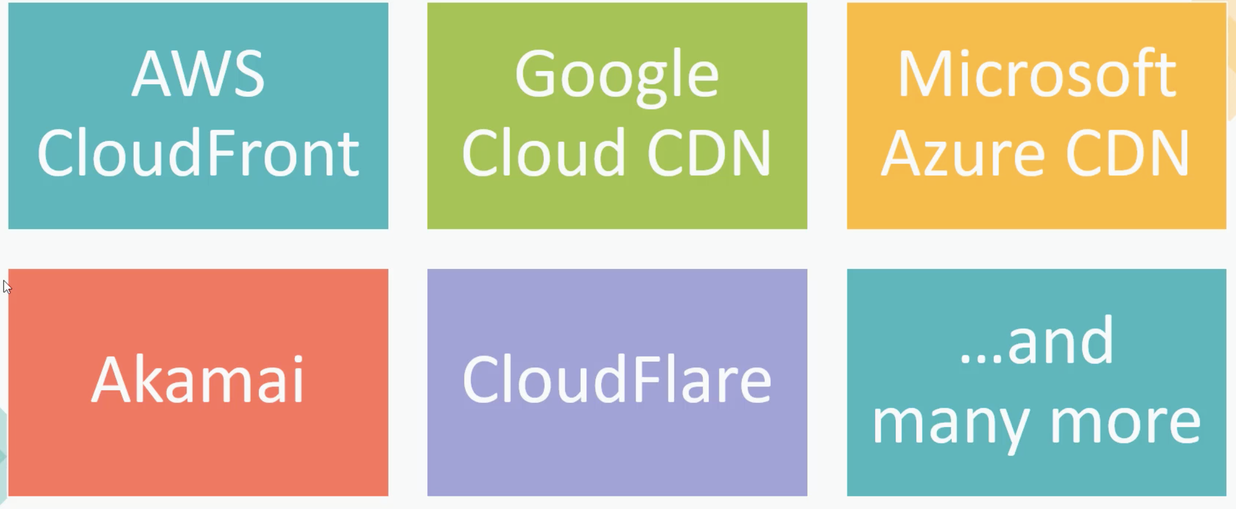
4. Resiliency
   1. Will address what if something goes wrong
   2. 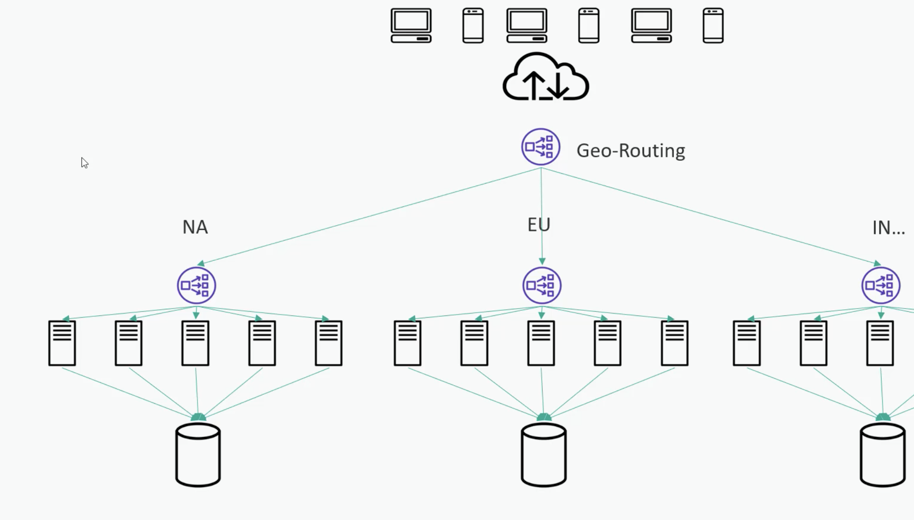
      1. Geo routing can handle region down it may slow but better
   3. Secondaries should be spread across the multiple racks/availability zones/regions
   4. Make sure system have enough capacity to service failure at any reasonable scale
   5. We may need to balance btw budget and availability
5. Distributed storage solutions
   1. Services for scalable, available, secure, fast object storage
   2. Use cases: data lakes,websites,backup,big data
   3. Highly durable
   4. Amezon s3 offers 99.99999 durability
   5. Below are the popular solutions
      1. Amezon s3
      2. Google cloud storage
      3. Azure
      4. Hadoop HDFS
         1. 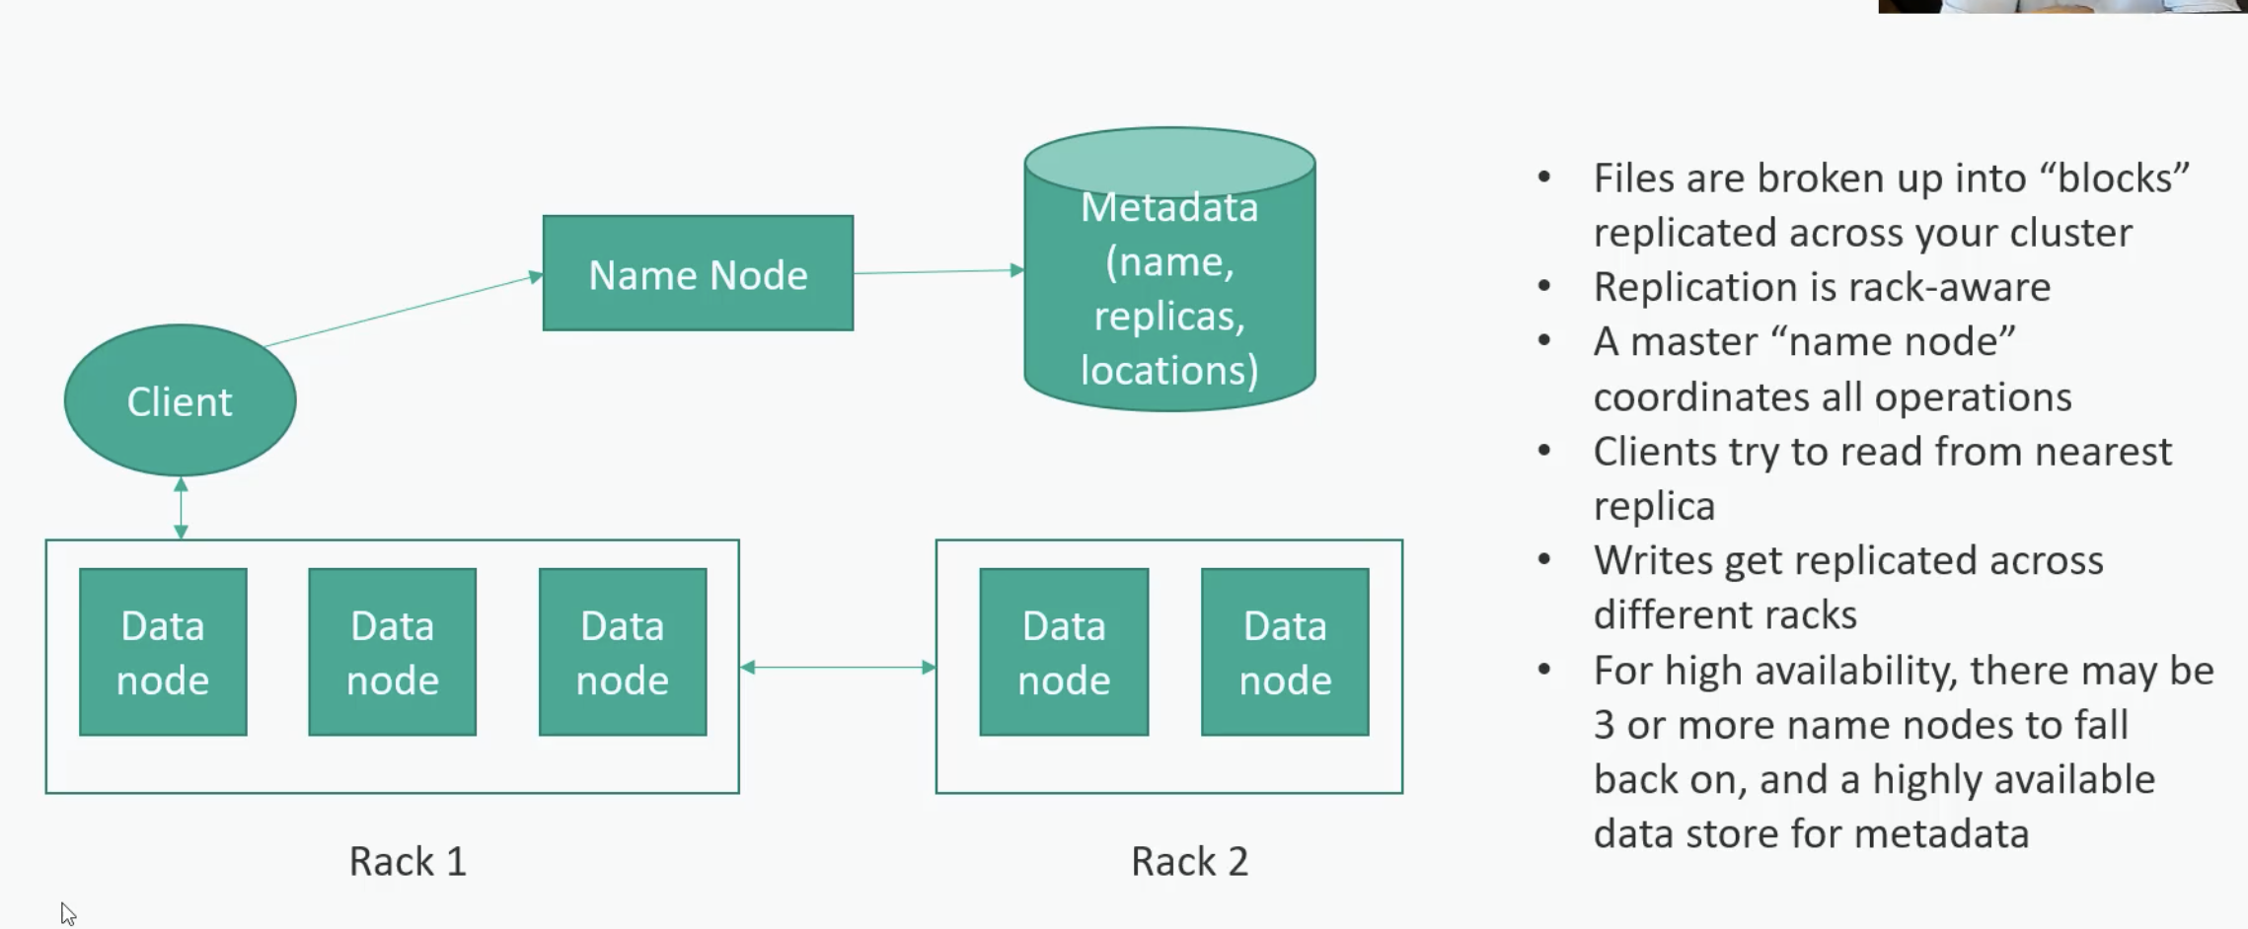
6. Algorithms and Data structures
   1. Linked list
      1. Single linked list
         1. 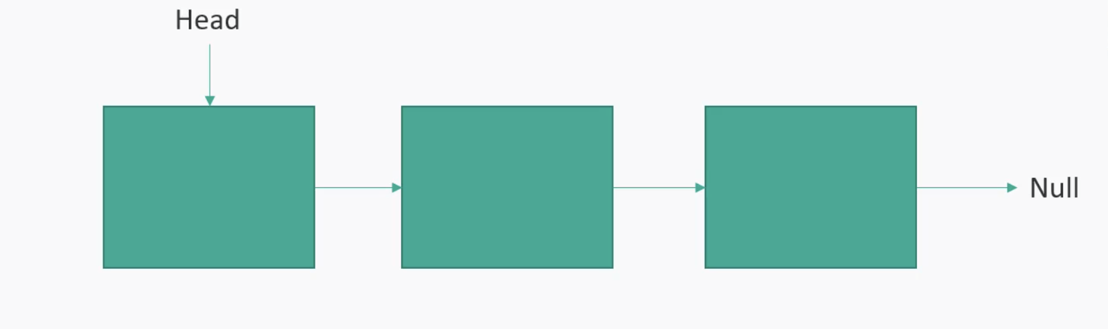
            1. Dymanically grows
            2. Access is O(n)
            3. Insert at head O(1)
            4. Insert in end O(n)
            5. Best use of sequential acess
            6. Also good for stacks(LIFO) or queues (FIFO) if you keep track of tail as well
            7. Low memory requirement
      2. Double LI
         1. 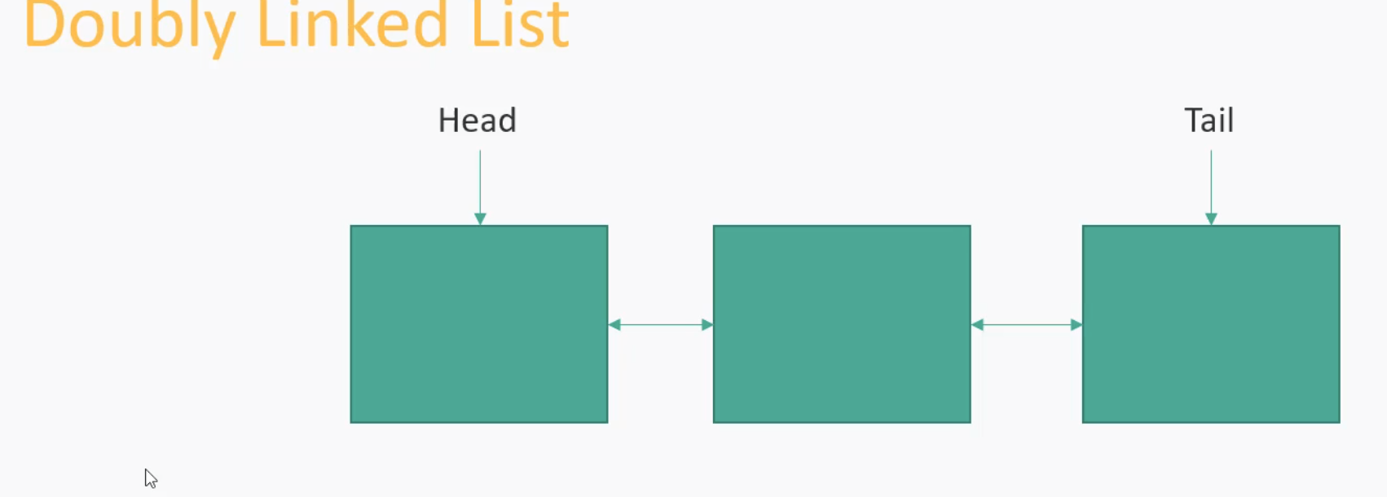
            1. Each node have next and previous
            2. Insert O(1)
            3. Access is still O(n) but practically its fast as we can start at any end
            4. Usefull for Deque
            5. MRU always moves most recent access to head
   2. Binary Tree
      1. 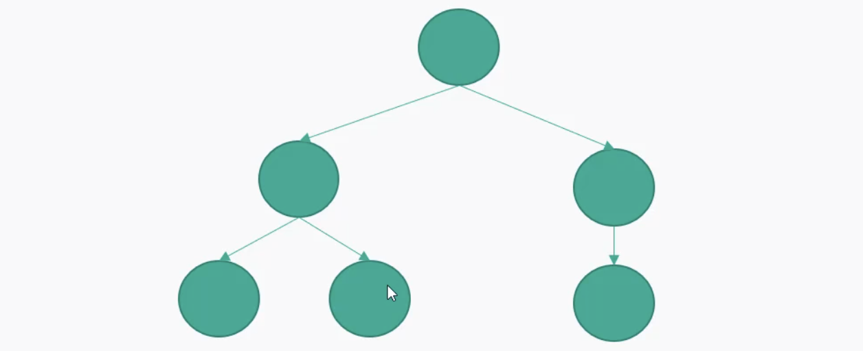
      2. Each element has left and right child
      3. If the left and right ordered (left means less than) its binary tree
      4. Access is O(log(n)) on average in worst O(n)
      5. Insert delete also O(log(n))
   3. Hash table
      1. 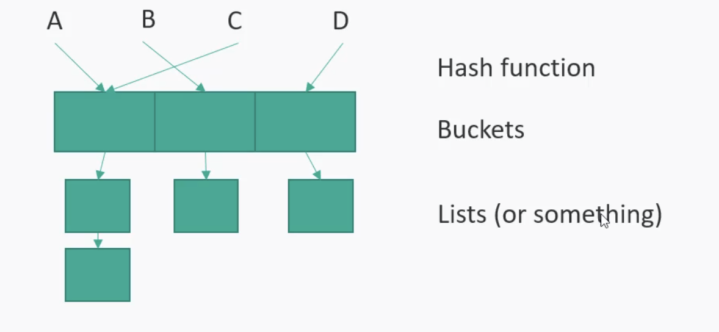
      2. Hash function quickly map some keys in bucket
      3. Hash collision can happen
      4. Insert/lookup Best O(1) in worst O(n)
   4. Graphs
      1. 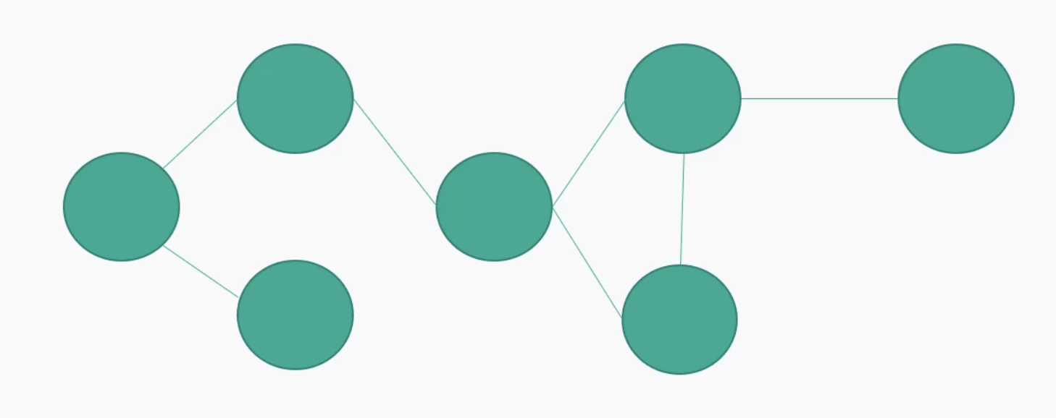
      2. Consists of nodes(vertices) that can be connected in orbiter ways(edges)
      3. For example, friends in social network, paths in city,networks in general
      4. Traversal strategies breath first search (BFS) and depth first search (DFS)
      5. Access O(V+E)
   5. Linear Search
      1. 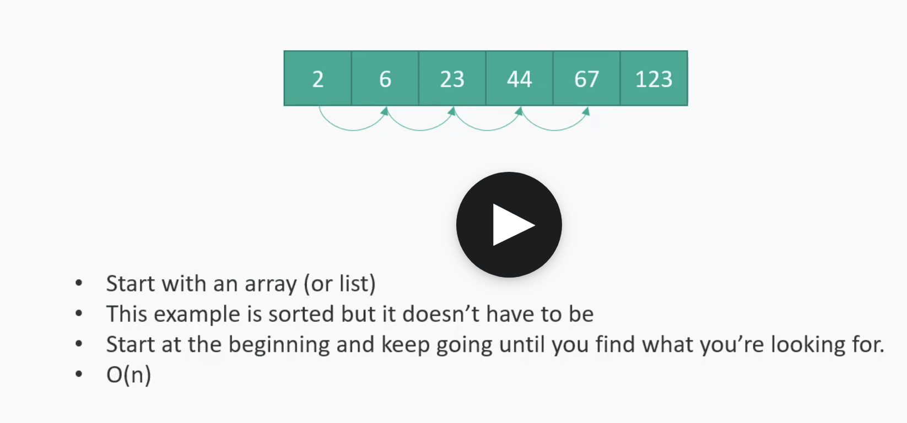
   6. Binary Search
      1. 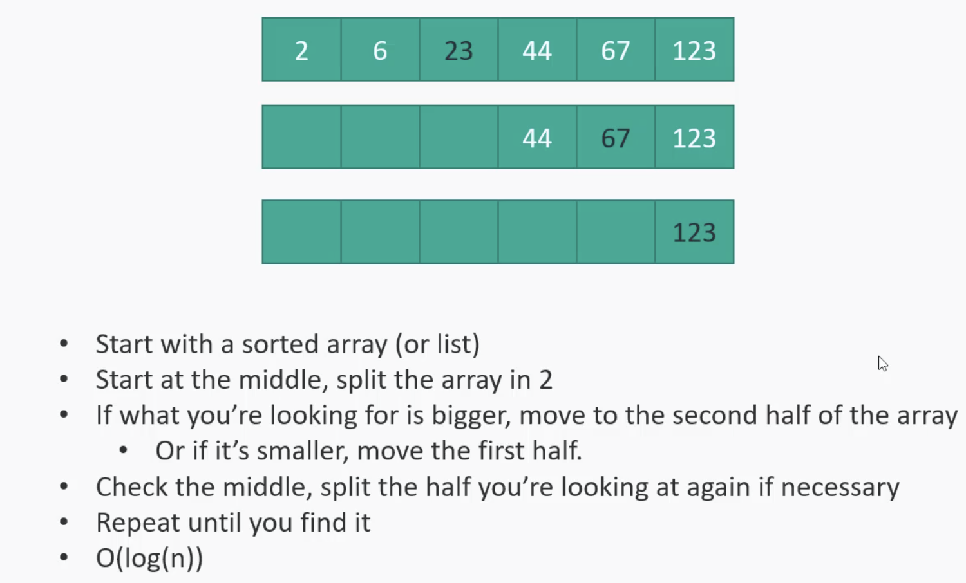
   7. Sorting algorithms
      1. Insertion Sort
         1. The best is O(n) and worst is O(n2). Its ok for small or mostly sorted list
      2. Merge Sort
         1. O(n log(n))
         2. Scales well to large list
      3. QuickSort
         1. O(nlog(n))
         2. Very fast unless you hit the worst-case scenario of O(n2) due to poor choice of pivot point
         3. Some complex implementations to avoid that
      4. Bubble sort
         1. O(n2).
         2. Simple but inefficient
7. Working with big data
   1. Messaging queue
      1. MQ as a scaling tool
         1. Decouples consumers and producers
         2. So if the consumers get backed up that’s ok
         3. Ex : Amazon SQS service
            1. Single consumers Vs. pub/sub
         4. This is different from streaming data(generally real time,massive data)
         5. 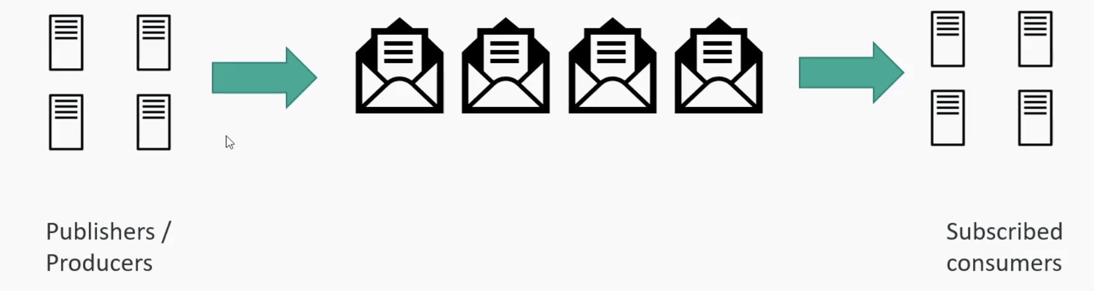
   2. Apache spark
      1. 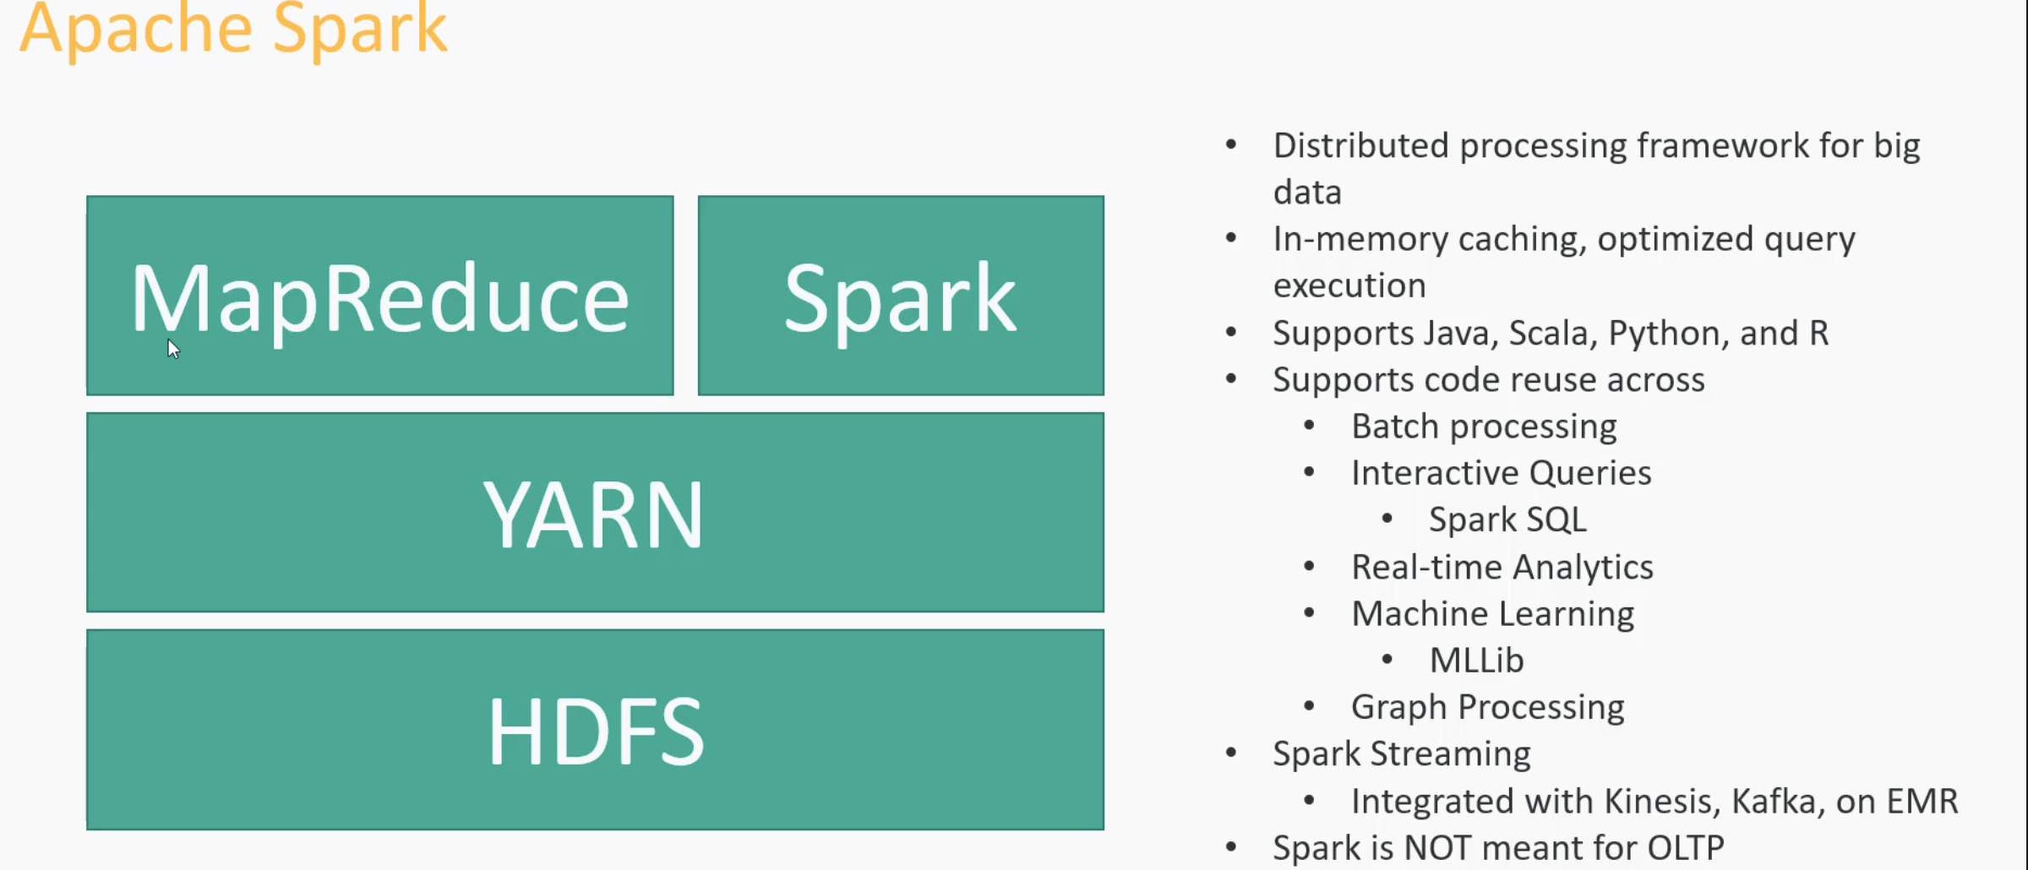
      2. OLTP : online transaction processing
      3. Its replacement for map reduce.it faster than map reduce
      4. 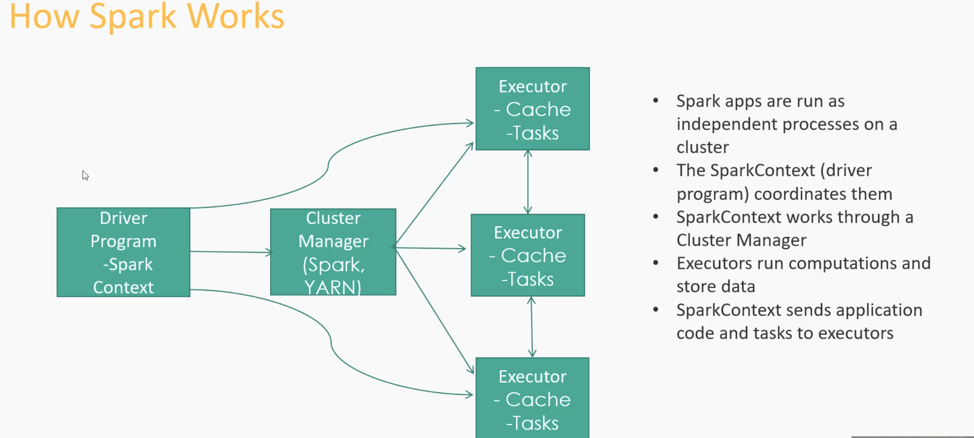
      5. 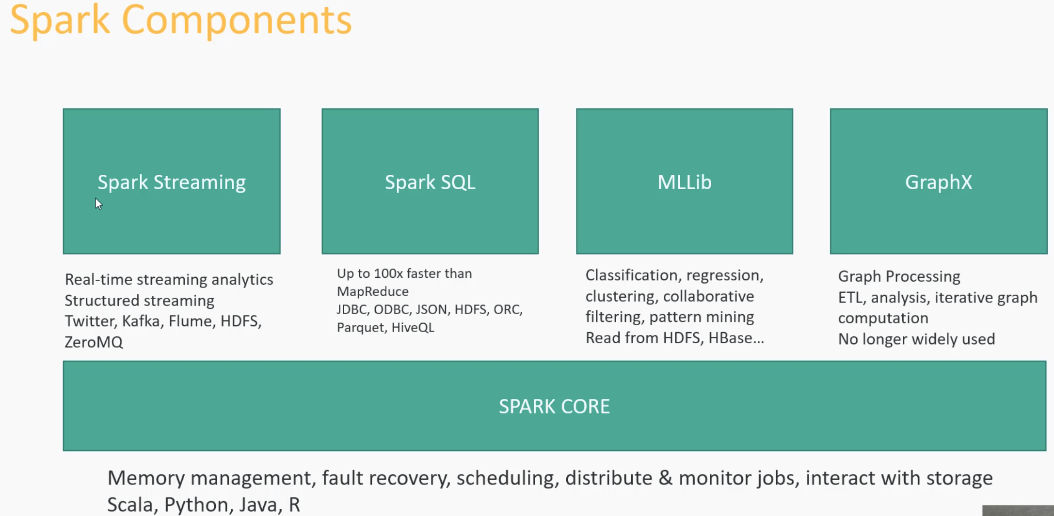
   3. Cloud computing
      1. 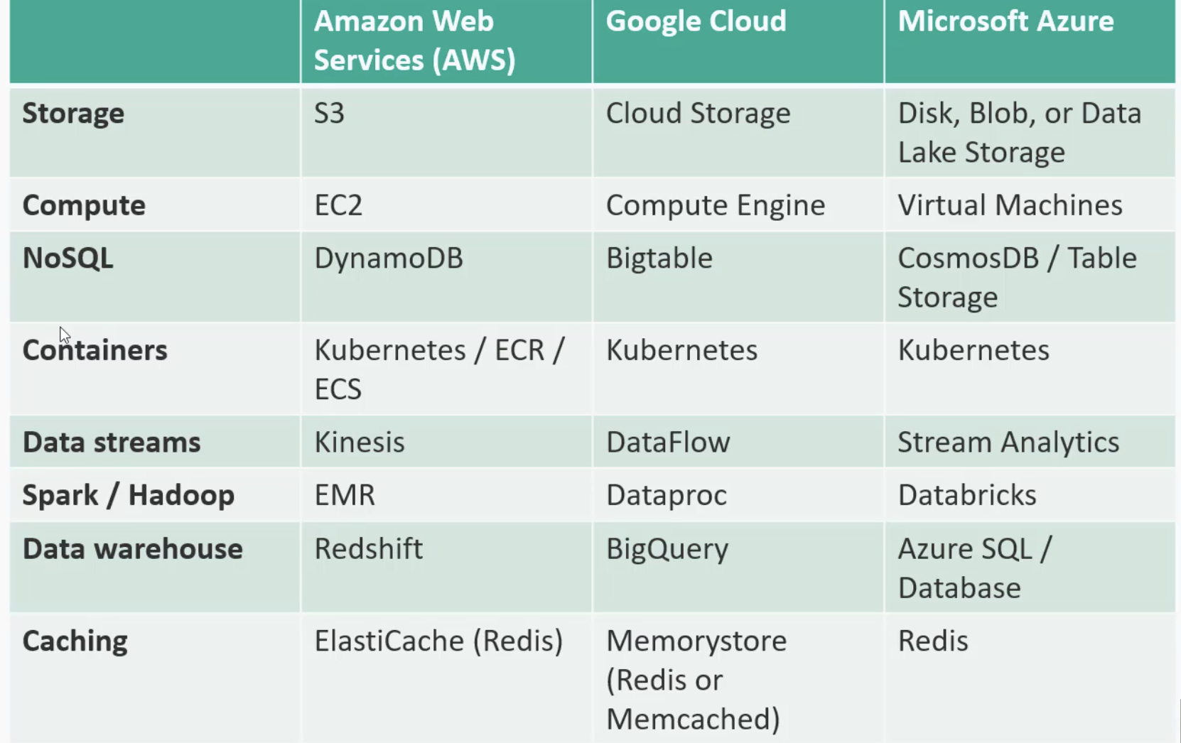
      2. 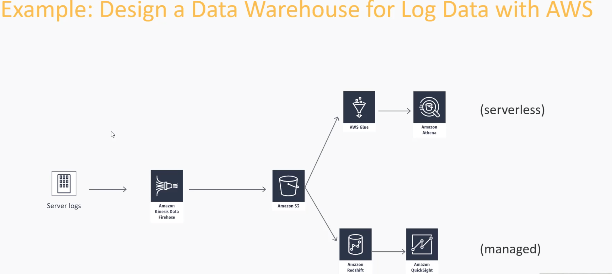
      3. Hybrid clould
         1. Clubbing private and public cloud
         2. Allows easy scaling of on -premise system
         3. Allows for regulation that required certain data in on premise
         4. Multi cloud is – more than one public cloud provider
         5. Requires bridge btw your data center and the cloud(its specific to provider)
8. Interview strategies
   1. Working backwards
      1. Start by clarifying the requirements
         1. Ask lot of questions
         2. Start from customer experience to define your rewquirements
         3. You tube example
            1. How will user discover vedios?Do we need to thinkabout building a searc engine?A recommended engine? An advertise engine ?
            2. Use this to limit the scope of what you are being asked to do
            3. Understand the customer experience you are being asked to deliver
            4. Identify who are customer
            5. What are the usecases
            6. Which use cases do you need to concern yourself with
      2. Defining requirements
         1. Scale of the requirement
            1. Nail down scale of the system .is it hundreds or millions

This will inform you on need for horizontal partitioning

How often users coming? what transaction rate do you need to support?

* + - 1. Scale of data
         1. Hundreds of videos? Millions?
      2. Some internal tool might not need this level of complexity,however
         1. Always prefer that simplest solution that will work
         2. Vertical scale still has its place
      3. Define latency requiring
         1. How fast is fast enough

This confirms need for caching and CDN usage

Try to express this in SLA(i.e., 100ms at three-nines for given operation)

* + - * 1. You tube example

Caching video recommmandations

Caching video metadata,description..etc

* + - 1. How much downtime can you tolerate
         1. Is being down a threat to business? Or just inconvenient?
         2. If former we need to design high availability

Opt for redundancy across many regions/racks/data centers for simplicity or frugality

* + 1. Design strategies
       1. Don’t just calm up for 10 min while think about thinks
       2. Clarify the requirements. Define the constrains of what you need to build
       3. Think out loud about solutions you are considering to meet those requirements
       4. Give change to interviewer a chance to steer in different direction before you start diving into details
       5. Sketching our designing
          1. 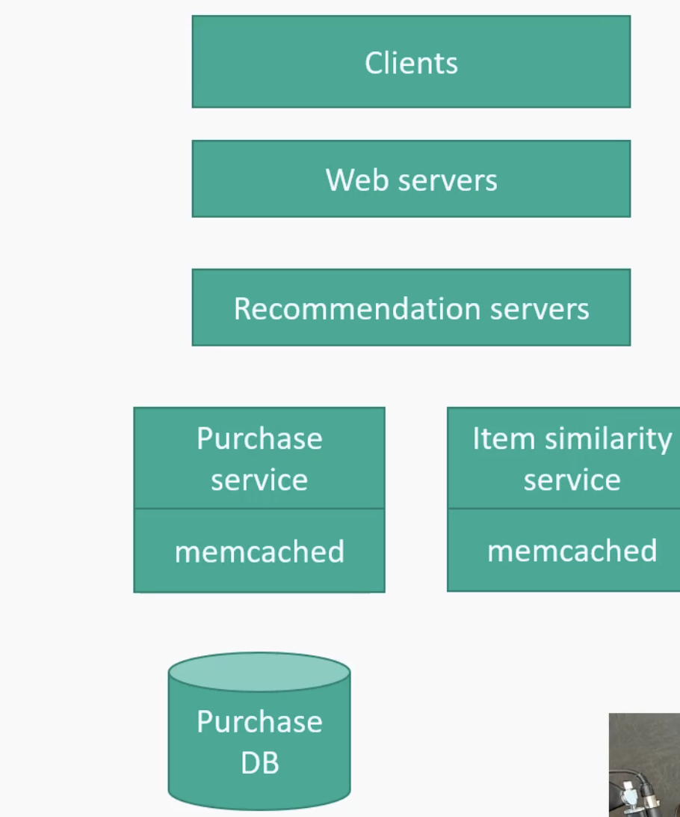

Start with high level components

Work backward if you can

Then flush out each component as time permits

How do they scale?

How are they distributed for availability

Let the interviewer talk, listen to then

Identify bottlenecks, maintenance, costs concerns as you go-show that you understand the tradeoffs of the generally doesn’t matter

Notation and format generally doesn’t matter much as long as you communicate what it means

Counter attacks from interviewer

Will try to poke holes in ur design

What happen if X fails

What happens sudden surge in system

Did you meet scaling and availability requiremets you define

Does ur system covers the use cases

How would you optimize or simplify and better

How will you monitor this system

1. Mock interview
   1. URL shorting services
      1. What scale of we are taking about
      2. Any restrictions on special chars
      3. How short is short
         1. If we are using lowercases and numbers al together 36 chars usually 6 chars enough so we can generate 366 nearly 2 billions
      4. How about vanity of url? Can people specify their own URL if available?
      5. Do let then edit and delete short urls once created
      6. How long shorten URL lasts
      7. We need below answers
         1. What API would you need to implement this system
            1. Generation logic

Convert long url ID which can be stored in DB into base 36 encoded 0-26 represents a to z and 26 to 36 is numeric

* + - * 1. Add new url :POST

Long url,UserID(Optional) 🡪 status,short URL

What if someone else already used this url?

* + - * 1. Add new vanity url : POST

Long url,userid,vanity url 🡪 status

* + - * 1. Update url : PATCH

Long url,userid, updated log url 🡪 status,existing short url

* + - * 1. Delete url : DELETE

Long url, userID🡪 status

* + - * 1. Display mapping :GET

Long url,userid 🡪 status,short URL

* + - * 1. Redirect :GET (301)

Short url 🡪 redirect to long url

301 is permanent redirect 302 is temperoroly

301 is suggest as browser case cache this where as 302 has to hit the server repeatedly

* + - * 1. 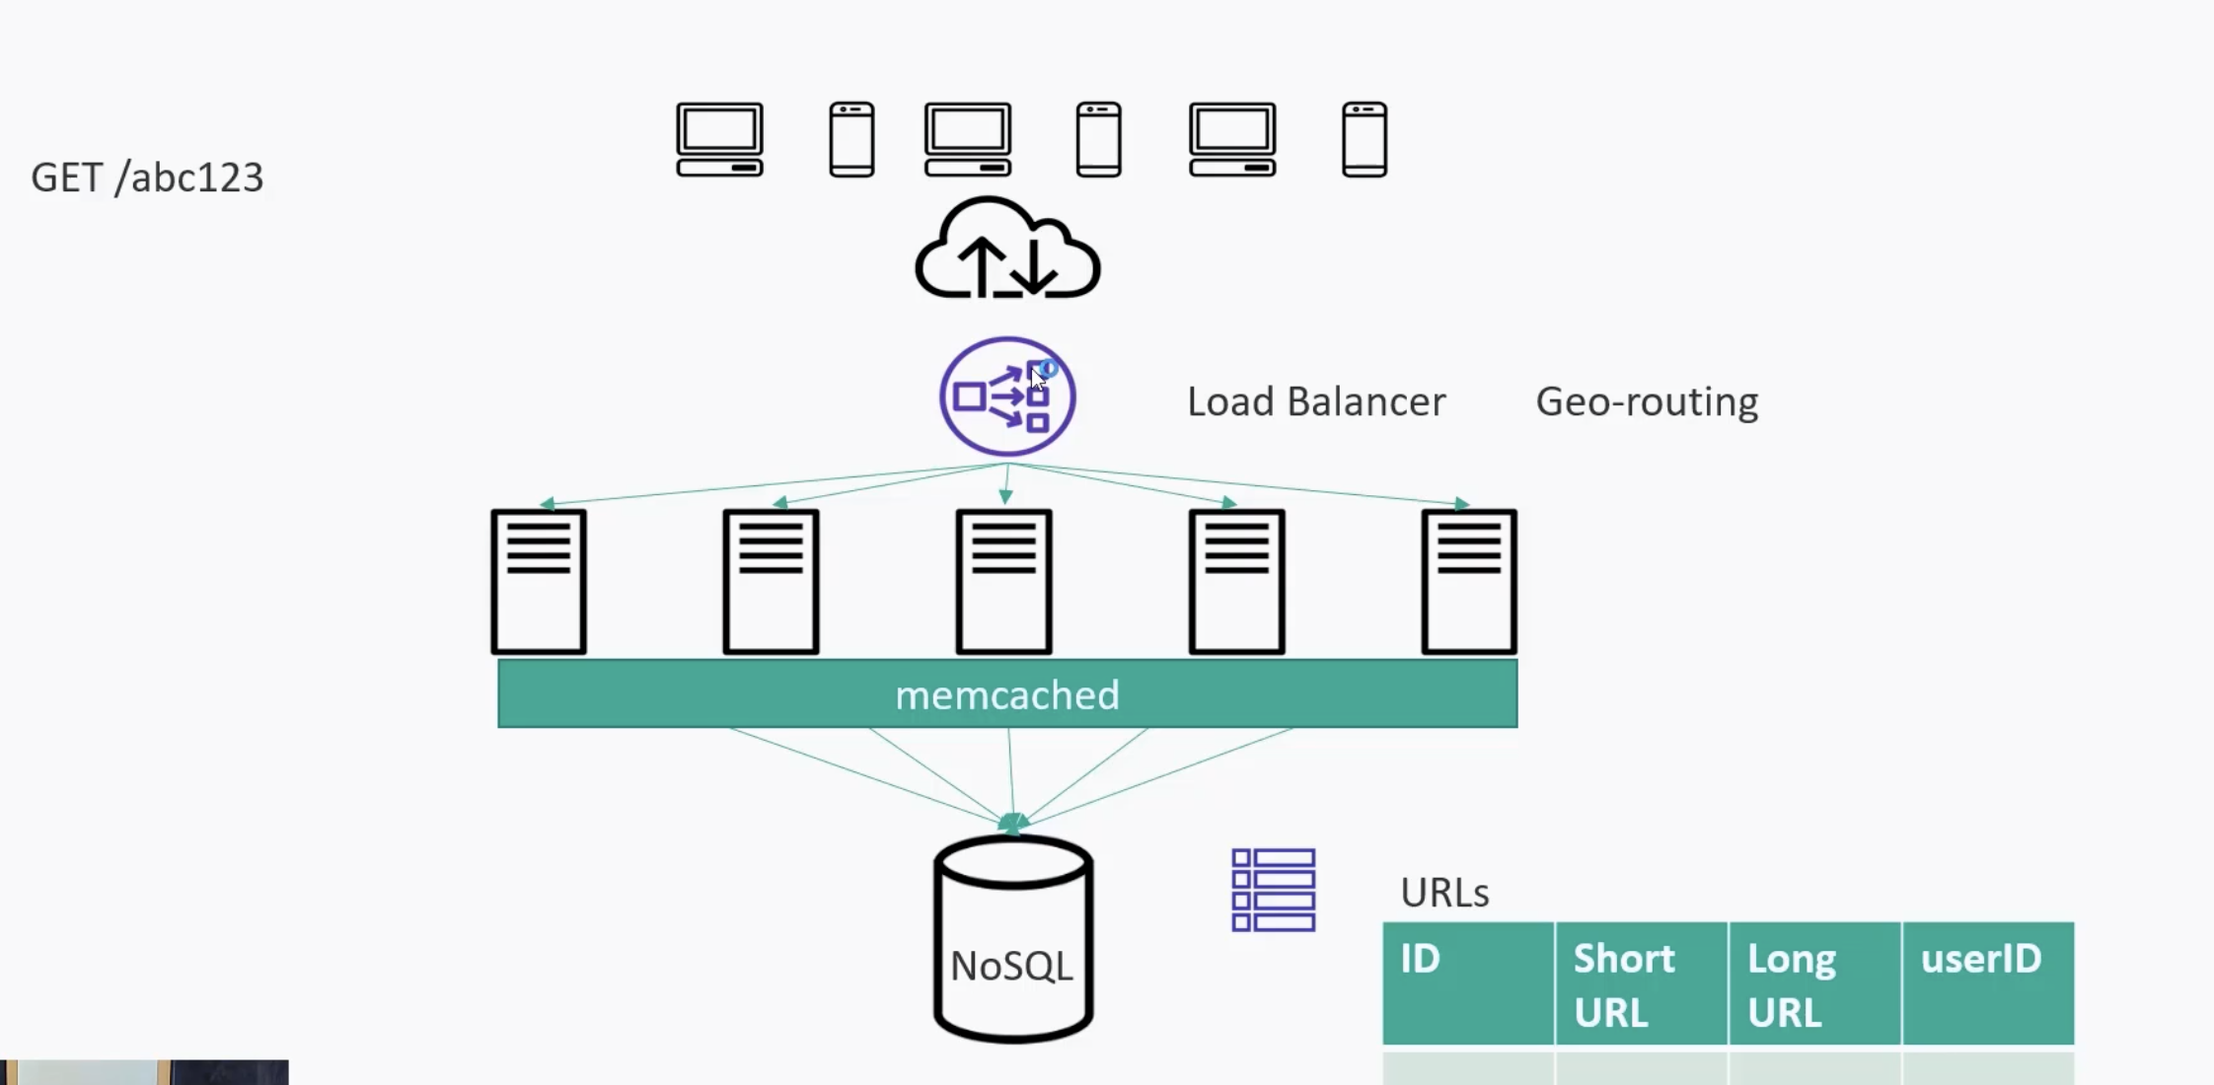
      1. How does the redirection work at massive scale?
  1. Restaurant reservation system
     1. Is it just for one restaurant or any number of restaurants like Open table or something?
        1. Many restaurnets
     2. Alright ,lets think about user experience first. A user will want to select to select restaurant, enter by party size, find list of available times near the time they want, lock in their reservation,and get some sort of confirmation via SMS somthing. they will also need some way to change or cancel reservations?
     3. Data needed
        1. 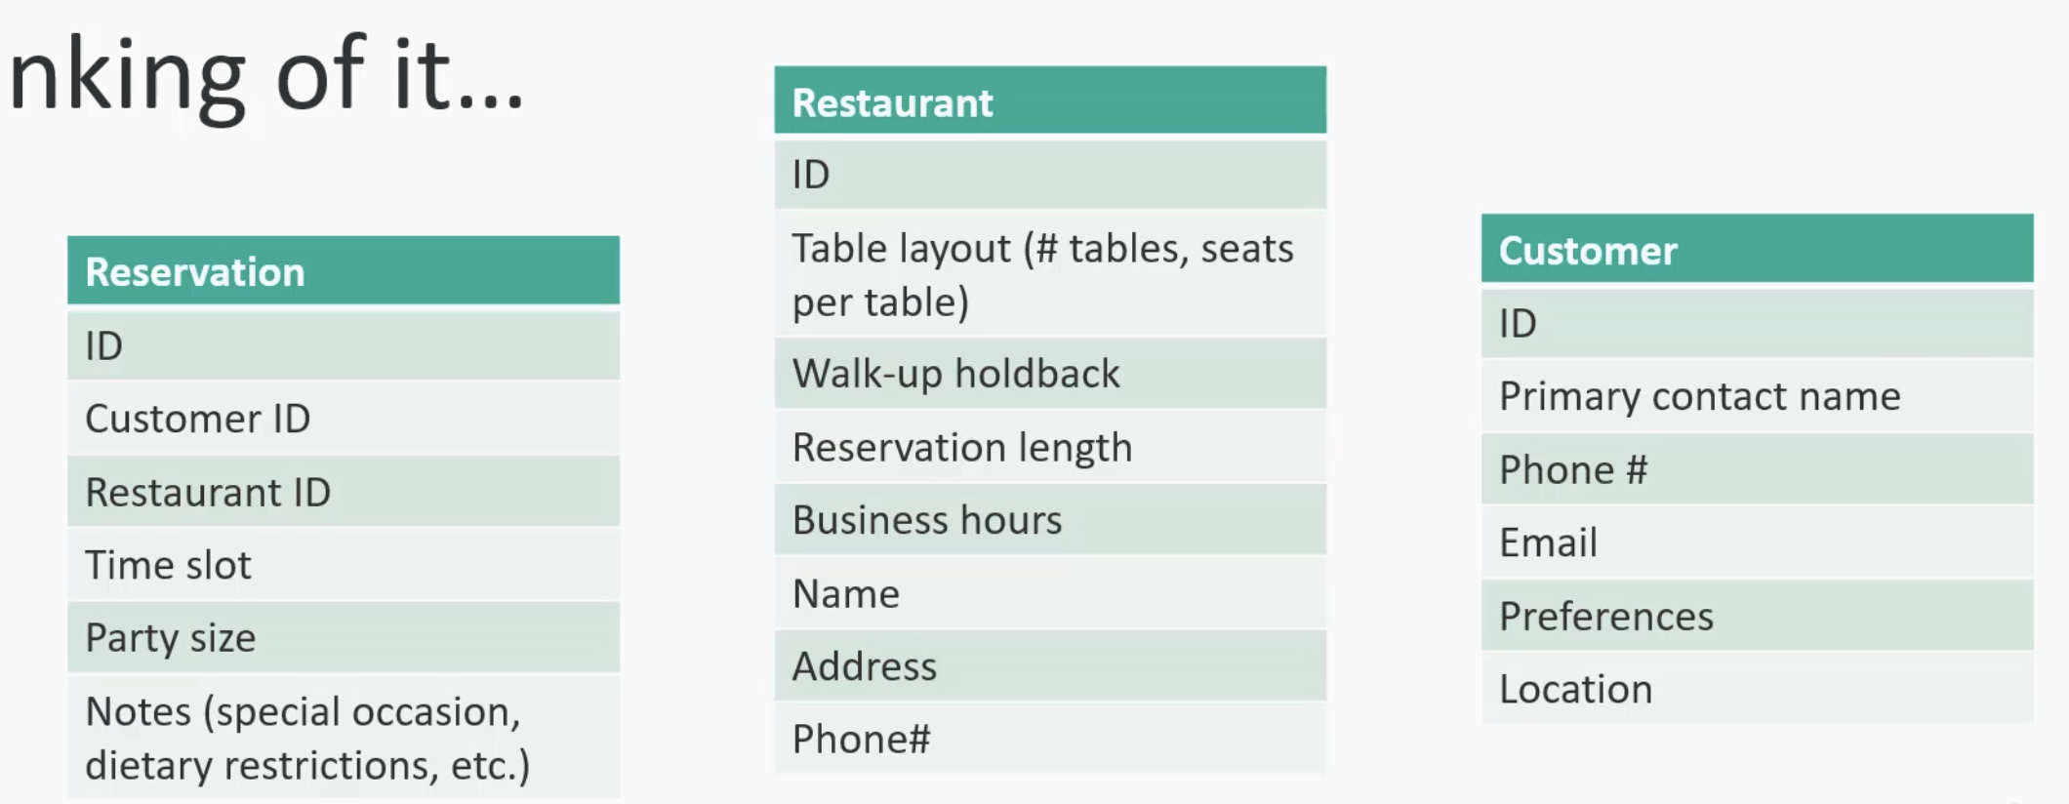
        2. 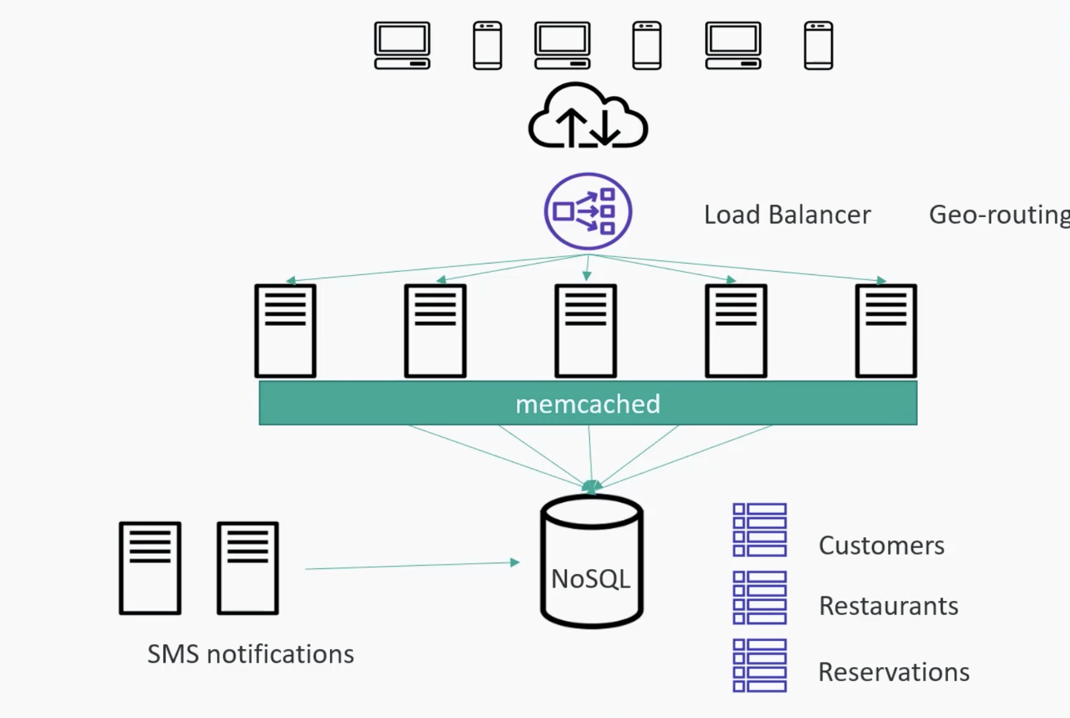
        3. Caching can be used for customer or restaurants data as it may need rare updates
  2. Web crawler
     1. Entire web or just few sites?
     2. If whole web then its billions of pages. How often crawled
        1. Weekly once
     3. So we need to check pages we have crawled before to see if any update ritht
        1. Yes
     4. Ok. Do we need to store copy of every page as we go? does it includes images
        1. Yes. But for now html pages would be fine but it would be nice if it supports images aswell in future
     5. What about dynamic content? Stuff that rendered in client side
        1. For now kept aside but designed that can be extended later
     6. What is the main purpose of this crawler
        1. To building search engine
     7. 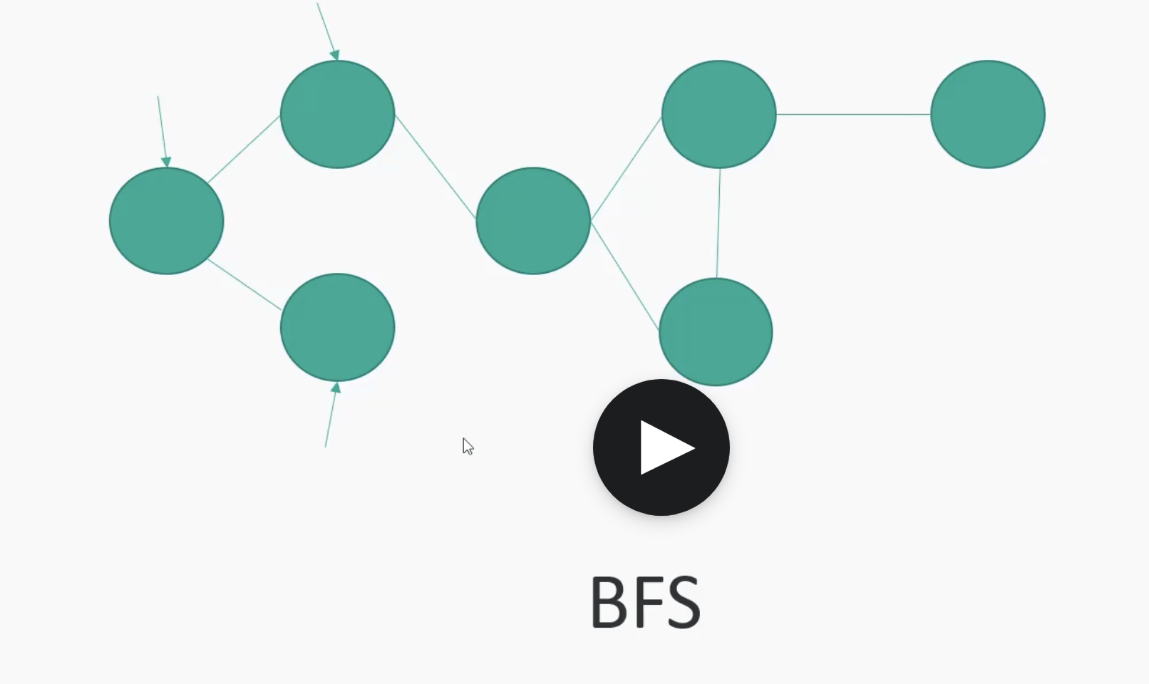
        1. BFS should be better approach each node ay have finite number of links
        2. If DFS it will go till the end of each edge.. its like take time for ever as its massive data
     8. 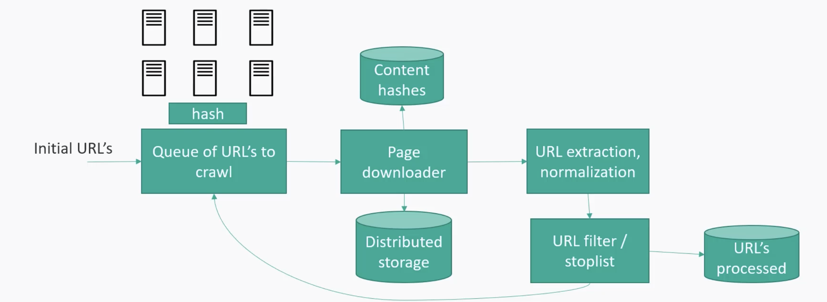
     9. 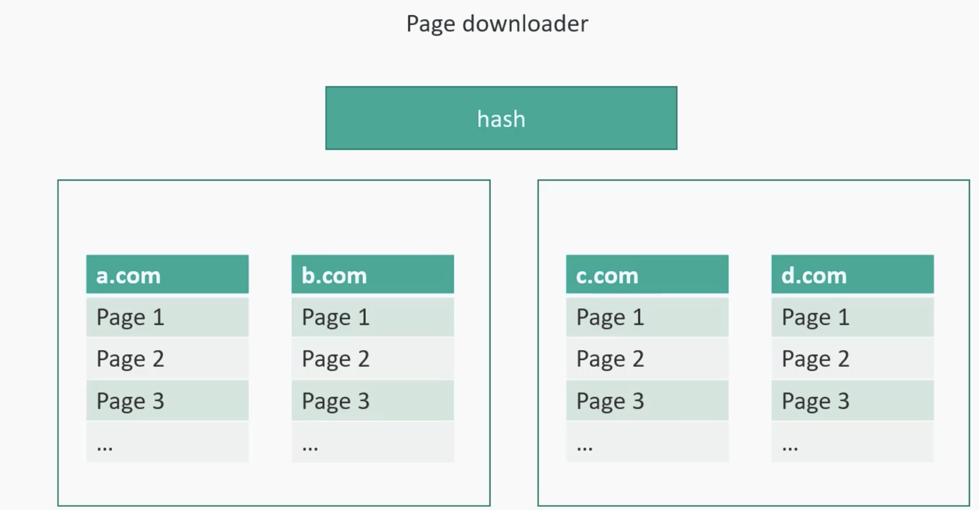
  3. Top-sellers
     1. Is this top sellers across the entire site or broken down by category
        1. By category
     2. How up-to date do to the result
        1. Mostly by day
     3. Algorithm
        1. 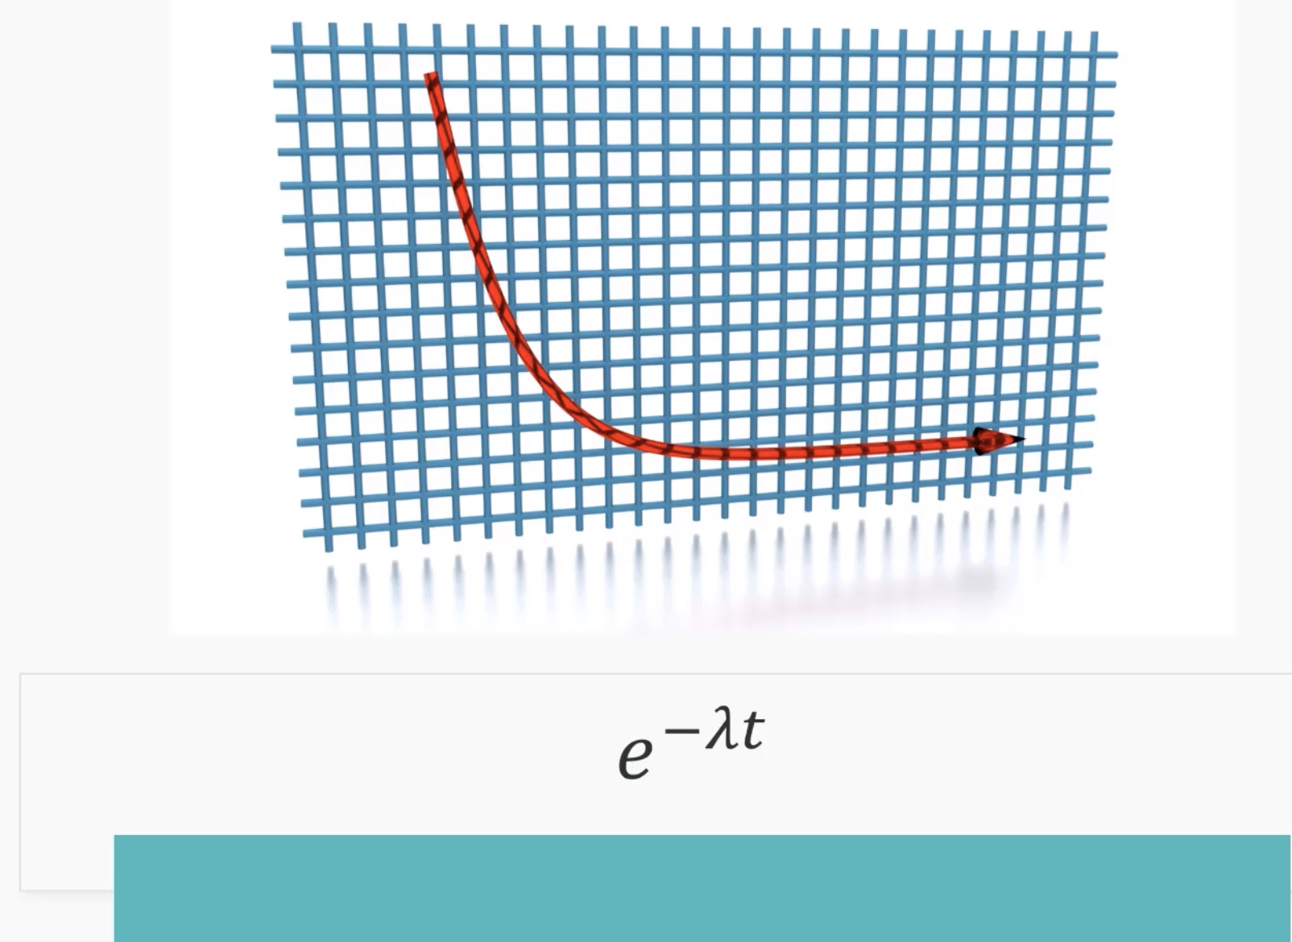
        2. 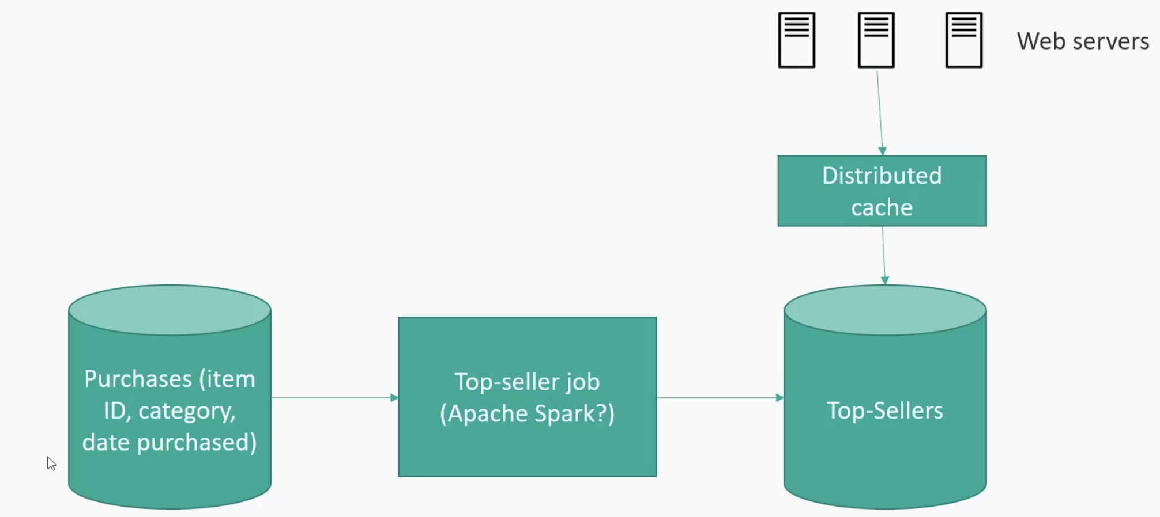
  4. Video streaming